Here is an example of what you will submit for your SQL Script. You need to include all three parts: ERD, Create Table Script (DDL) and Insert Table Script (DML).

1- Included your ERD. This is a sample ERD.

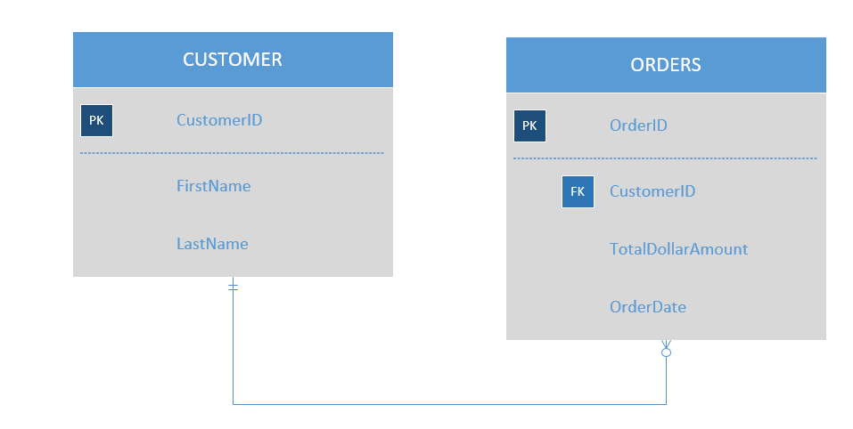
2- Include your create table DDL. The following is a sample DDL script created from the above ERD.
CREATE TABLE CUSTOMER (CustomerID int Primary Key, FirstName varchar(30), LastName varchar(30))
CREATE TABLE ORDERS (OrderID int Primary Key, CustomerID int FOREIGN KEY (CustomerID) REFERENCES CUSTOMER(CustomerID), TotalDollarAmount money, OrderDate datetime2)

3- Insert statements for all tables. You need to insert a minimum of five rows for each tables. The following is a sample DML script created from the above ERD.
INSERT CUSTOMER VALUES (1, “Patrick”, “Nieland”);
INSERT CUSTOMER VALUES (2, “Herbert”, “Rinkleff”);
INSERT CUSTOMER VALUES (3, “Clint”, “Eastwood”);
INSERT CUSTOMER VALUES (4, “Robert”, “De Niro”);
INSERT CUSTOMER VALUES (4, “Paul”, “Newman”);
INSERT CUSTOMER VALUES (13342, 1, 2.34, ’12-01-16 12:21:05’);
INSERT CUSTOMER VALUES (13345, 1, 45.34, ’12-15-17 12:24:45’);
INSERT CUSTOMER VALUES (13342, 1, 2.34, ’12-01-16 12:21:05’);
INSERT CUSTOMER VALUES (13355, 3, 775.34, ’4-15-17 12:24:45’);
INSERT CUSTOMER VALUES (13366, 3, 52.34, ’3-01-16 12:21:05’);

